Omar Moustafa

900222400

January 16, 2023

DSCI 1411

**Assignment 4**

1. **Read the R dataset murders. Load the necessary packages. [Hint: use ?murders].**
   1. Write the definitions of the variables including the unit of measurement and type.



Variable 1: State

* Type: Character
* Unit of Measurement: US state

Variable 2: Abb

* Type: Character
* Unit of Measurement: Abbreviation of US state

Variable 3: Region

* Type: Factor
* Unit of Measurement: Geographical US region

Variable 4: Population

* Type: Numeric
* Unit of Measurement: State population (2010)

Variable 5: Total

* Type: Numeric
* Unit of Measurement: Number of gun murders in the state (2010)
  1. Examine the contents of the data using str().

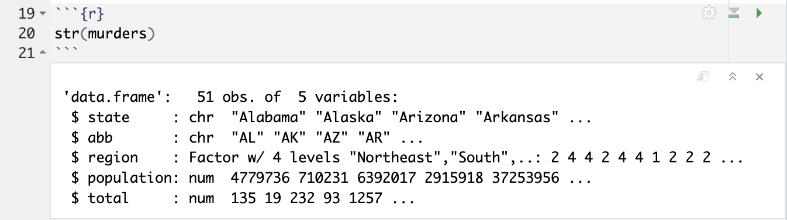

* 1. Write the R commands that are needed to create an object which contains the data, where the states are ordered in decreasing order of the total number of gun murders.



* 1. Write the R commands that are needed to create an object which contains the data, where the States are ordered in decreasing order of the per capita the total number of gun murders.



* 1. Write the R commands that are needed to create an object which contains the data, where the States are ordered alphabetically but in reverse order (e.g., Alaska comes before Alabama.



1. **Read the R dataset mtcars. Load the necessary packages.**
   1. Write the definitions of the variables including the unit of measurement and type.



Variable 1: mpg

* Type: Numeric
* Unit of Measurement: Miles/(US) gallon

Variable 2: cyl

* Type: Numeric
* Unit of Measurement: Number of cylinders

Variable 3: disp

* Type: Numeric
* Unit of Measurement: Displacement (cu.in.)

Variable 4: hp

* Type: Numeric
* Unit of Measurement: Gross horsepower

Variable 5: drat

* Type: Numeric
* Unit of Measurement: Rear axle ratio

Variable 6: wt

* Type: Numeric
* Unit of Measurement: Weight (1000 lbs)

Variable 7: qsec

* Type: Numeric
* Unit of Measurement: 1/4 mile time

Variable 8: vs

* Type: Numeric
* Unit of Measurement: Engine (0 = V-shaped, 1 = straight)

Variable 9: am

* Type: Numeric
* Unit of Measurement: Transmission (0 = automatic, 1 = manual)

Variable 10: gear

* Type: Numeric
* Unit of Measurement: Number of forward gears

Variable 11: carb

* Type: Numeric
* Unit of Measurement: Number of carburetors
  1. Examine the contents of the data using str().

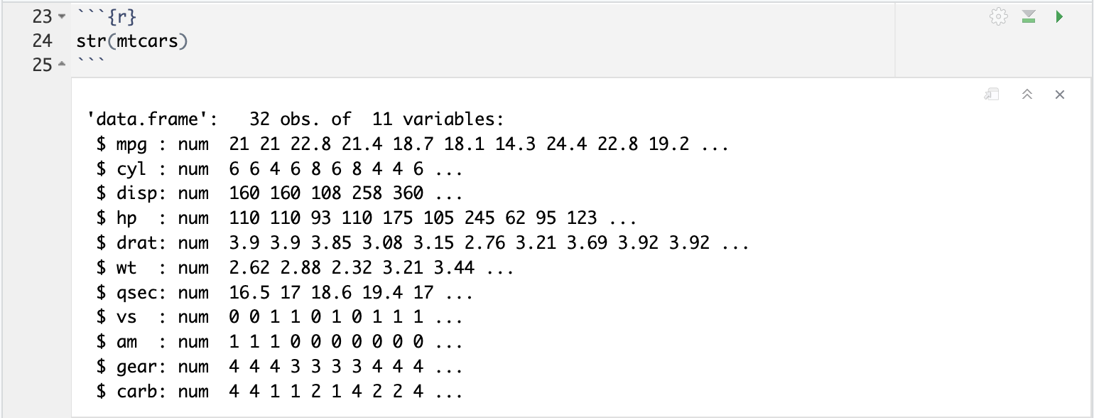

* 1. Write the R command that identifies the heaviest car.

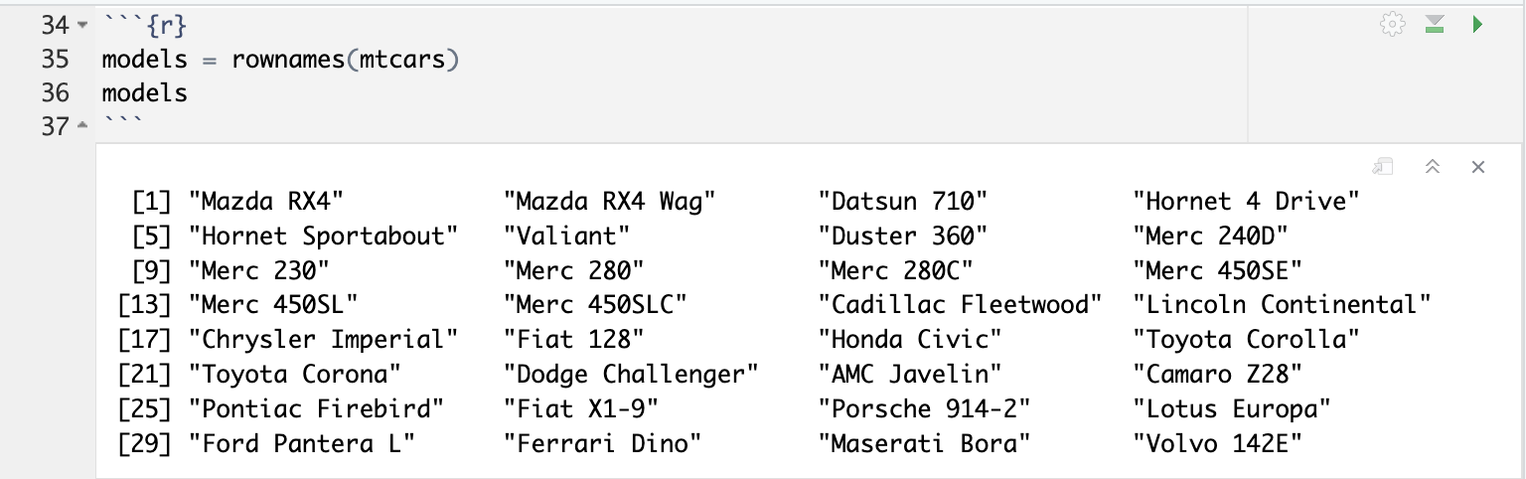

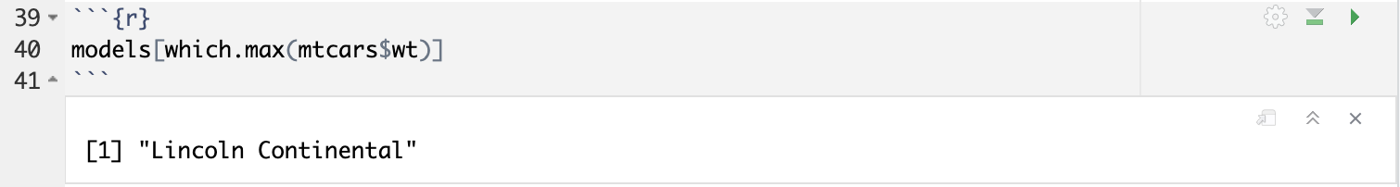

* 1. Write the R command that identifies the car with the least gasoline consumption.

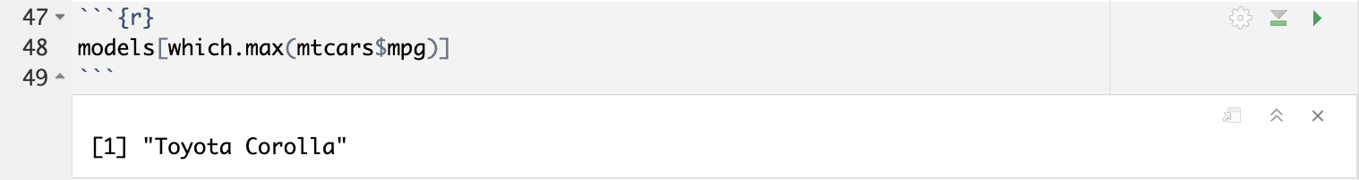

* 1. Write the R command that computes the number of cars in this dataset with automatic transmissions.

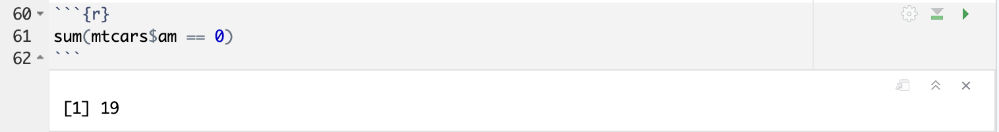

* 1. Write the R command that computes the number of cars with 5 cylinders.

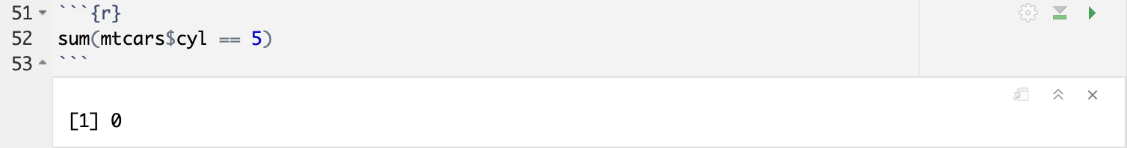

* 1. Use R to transform the variable mpg to gpm.

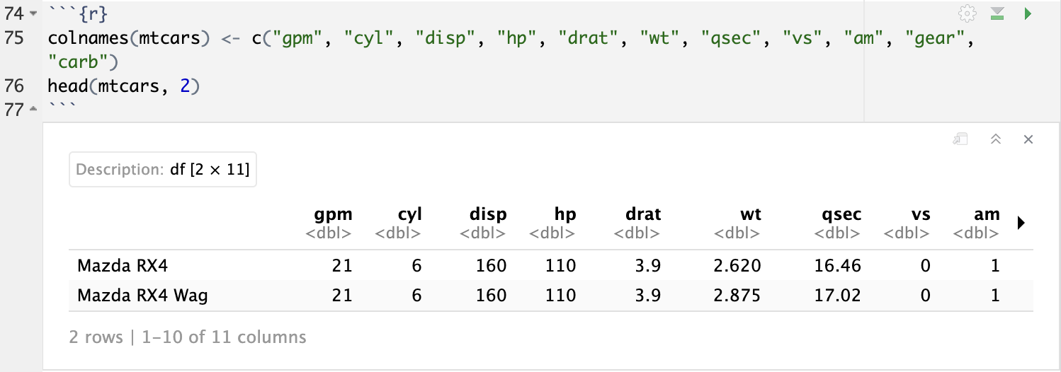

* 1. Use R to express the variable wt in kilograms.

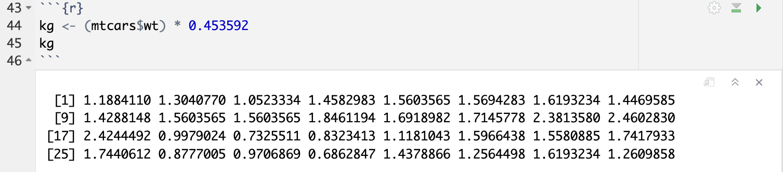

* 1. Use R to express the variable qsec in kilometers.

